Form the attached file and previous Being an 20 year old experienced Developer Architect what you understand by this docuemnt. find the missing (gaps, links, integration, dependencies,), bugs, Failed Scenarios, validations, conditions. We have to improve the performance of the Android app for 100+ devices logged in one/same time and have MLM level device connections (one to many (but no data share (untill allow/approved)). with lowest battery consumptions. Do you think or suggest being a 20 years experienced Agentic AI (Architect(frontend(UI/UX (best human experience (adding basic, essential Elements(in context of testing various scenarios and pending items)))),backend(oops based MVC or MVVM), database (database mapping relationship between tables or restructuring )), Programmer, Developer, Designer) Agents for every page. have you, covered for all the screens or page requirements and updates till now. Did you missed any thing or done mistakes or having bugs for UI/UX(scenarios based features must have are missing) because of pre-requisites, dependencies, integration, optimization and performance point of view. Also, identify and resolve all critical or silly bugs, dependency conflicts, integration issues, optimization opportunities, performance bottlenecks, security vulnerabilities, scalability concerns, and architectural inconsistencies. Validate all fixes, prevent regressions, and ensure every open branch is connected to a validated feedback loop leading to the optimal closure point. Add or update the User Manual (HUMAN IN LOOP activities step by step)
…
Enterprise Architecture Audit: Family & Friends Relational Matrix & Telemetry Mesh
Specification reviewed
Architecture gaps identified
Not yet production validated
I have reviewed the complete attached specification, including its nine Business Requirements (BR1 to BR9), UI elements, backend engines, database references, functional rules, and positive/negative test scenarios.
I am approaching this as a Principal Android Solution Architect, Senior Software Engineer, QA Architect, Security Architect and Agentic AI Engineering Lead, with a 20-year enterprise-engineering perspective.
My assessment is that this is a reasonably comprehensive functional blueprint, but it is not yet a complete enterprise-grade engineering specification.
There is an important distinction:
- A feature being documented does not mean it has been implemented.
- A backend function being mentioned does not mean its dependencies are connected.
- A successful UI test does not mean the underlying data is correct.
- A Firebase listener working with 2 devices does not mean it will work efficiently with 100+ devices.
- A privacy toggle does not establish end-to-end privacy enforcement.
My recommendation is not to start rewriting the screens. First, establish architectural correctness, security boundaries, data ownership, lifecycle management and performance requirements. Then validate each screen against those foundations.
1. What I understand from your document
Your document describes a Family & Friends device relationship and telemetry management subsystem, centred around:
FamilyFriendsActivity ⊃ FamilyFriendsViewModel
The intention is to create a relational network in which one primary device can manage multiple connected devices, organize them into different relationship categories, monitor permitted telemetry and execute authorized remote actions.
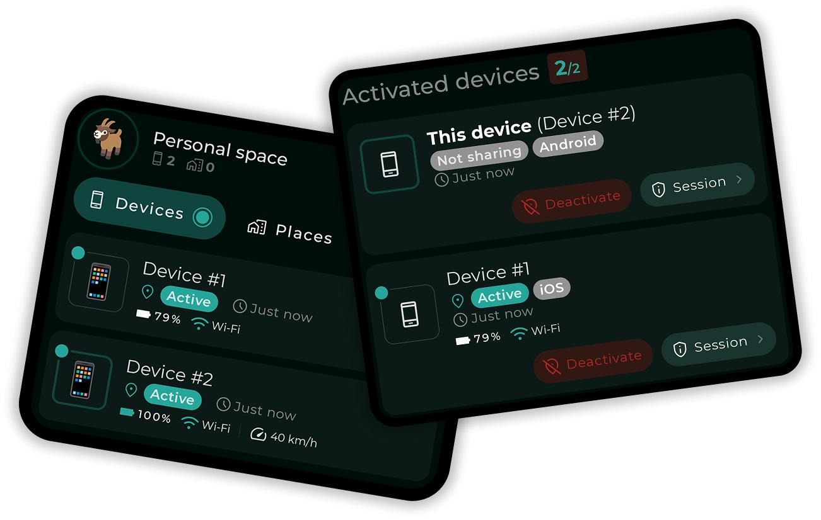
Functional architecture
BR | Business requirement | My interpretation
BR1 | Dual-tab navigation | Separate Family and Friends rosters
BR2 | Navigation and onboarding | Screen context, privacy, invitations and synchronization
BR3 | Host identity | Primary guardian/root device
BR4 | Search and sorting | Roster discovery and organization
BR5 | Relational tree | Hierarchical family/friend structure
BR6 | Device telemetry | Battery, online status, safe zones and location
BR7 | Remote actions | Ring, locate, rename, edit, unlink and reclassify
BR8 | Disaster recovery | Offline cache, cloud sync and roster restoration
BR9 | Empty states | Context-sensitive onboarding and recovery prompts
My architectural interpretation
The application is attempting to implement five interconnected systems:
- Identity Management: Who is the person, account, device and network node?
- Relationship Management: Which devices belong to which family/friend groups?
- Authorization Management: What information can each person/device access?
- Telemetry Management: Which approved information can be collected and transmitted?
- Device Orchestration: Which commands can one device issue to another?
These should be separate architectural domains, even if they are initially delivered within the same Android application.
This separation will become particularly important when the network grows beyond 100 devices.
2. The most important architectural decision
Critical design requirement
You mentioned:
One-to-many device connections, but no data sharing until explicitly allowed/approved.
I would make this the foundation of the entire architecture.
Connection must never automatically imply permission.
A device can be:
- Discovered.
- Invited.
- Paired.
- Authenticated.
- Registered in a group.
- Authorized for selected services.
- Authorized for selected data categories.
- Authorized for selected remote commands.
These are different states.
For example:
Recommended device lifecycle
- Device discovered
- Invitation accepted
- Identity authenticated
- Device paired
- Relationship established
- Privacy and permissions reviewed
- Individual data-sharing consent granted
- Authorized telemetry activated
- Continuous authorization and consent monitoring
Default security state
Paired = Connected, but no optional data-sharing permissions.
I would introduce an explicit PENDING_CONSENT state and make the initial permission policy deny-by-default.
This also means that location, battery, history, SOS, microphone, remote ringing and other services need independently defined permissions.
A user should be able to approve location while refusing history access, for example.
3. Critical findings: defects and architectural gaps
Priority 0: Must resolve before production
These are specification-level defects or high-risk design decisions. They are not confirmed runtime bugs because the attachment contains requirements, not the Android source code.
ID | Finding | Severity | Required correction
A01 | Default permission mask is 0xFF | Critical | Default to deny-all
A02 | Master password stored in SharedPreferences | Critical | Replace with server-verified authorization and secure credential handling
A03 | Pairing and permission approval are not separate | Critical | Introduce independent pairing and consent state machines
A04 | Client-side authorization is trusted | Critical | Enforce permissions in Firebase Security Rules and trusted backend
A05 | Cloud and SQLite described as one transaction | Critical | Implement transactional outbox and reconciliation
A06 | Global relationship scan during recovery | Critical | Restrict discovery to authenticated, authorized relationships
A07 | Remote commands have no expiry/idempotency contract | Critical | Introduce signed/authorized command envelopes
A08 | Unlink deletes multiple identity records | Critical | Separate membership unlinking from device/account deletion
A09 | Location privacy only specifies GPS broadcast suppression | Critical | Enforce privacy across all telemetry channels
A10 | No explicit concurrent-write conflict policy | High | Add versioning, conflict resolution and server timestamps
A. Permission and privacy defects
A01. Default permissions are dangerously permissive.
Your specification says:
Default mask = 0xFF (all permissions active)
This is the opposite of your primary business requirement.
Consider a newly paired child device. The device is connected, but the owner has not approved any data sharing.
The current specification potentially gives that device all permissions.
Recommended correction:
Permission | Default
Device identity | Allowed for pairing
Relationship membership | Pending approval
Location | Denied
Location history | Denied
Battery telemetry | Denied
SOS telemetry | Denied
Remote ring | Denied
Remote configuration | Denied
Profile access | Denied
Camera/microphone | Denied
Use an explicit permission enum or policy document rather than relying on a single ambiguous bitmask.
For example:
- IDENTITY_VERIFICATION
- LIVE_LOCATION
- LOCATION_HISTORY
- BATTERY_STATUS
- SOS_ALERTS
- REMOTE_RING
- SAFE_ZONE_STATUS
- PROFILE_READ
- DEVICE_CONFIGURATION
Each permission should have:
- Granted/denied status.
- Granting user.
- Receiving device.
- Scope.
- Timestamp.
- Expiry, where applicable.
- Revocation timestamp.
- Consent policy version.
A02. Master password protection is inadequate.
The current implementation proposes:
RegistryManager.getPurgeSafetyPhrase(context)
followed by a trimmed string comparison.
Problems:
- SharedPreferences is not an appropriate location for a plaintext master password.
- A local administrator-controlled secret cannot independently prove server-side authorization.
- No rate limiting is specified.
- No account reauthentication is specified.
- No audit trail requirements are specified for failed attempts.
- No protection against replay or unauthorized remote invocation is specified.
Replace this with an authenticated administrative challenge, recent reauthentication, server-side authorization and a protected audit event.
A03. Ghost Mode is incomplete.
The specification says Ghost Mode suspends cloud writes and intercepts outgoing telemetry.
But what about:
- Battery updates?
- SOS events?
- Last-known coordinates?
- Location history uploads?
- Pending offline events?
- Background workers?
- Cached location synchronization?
- Push notification payloads?
- Remote locate commands?
- Other devices requesting location?
Ghost Mode must define precisely which data streams are blocked, which safety exceptions exist, and whether pending events are deleted, retained locally or uploaded after consent changes.
A privacy setting must be enforced in the telemetry pipeline, not just in the screen.
A04. Fuzzy Mode needs a mathematical privacy specification.
Your document specifies Gaussian jitter with an approximate 800-metre radius.
Gaussian noise does not provide a guaranteed maximum displacement of 800 metres.
You need to define:
- Noise distribution.
- Standard deviation.
- Coordinate reference system.
- Whether noise is generated once or repeatedly.
- Whether repeated observations can reveal the original location.
- Whether noise persists across sessions.
- How GPS accuracy and noise interact.
- Whether the original coordinate is ever transmitted.
Repeated independent random displacement can actually make approximate location reconstruction easier.
I recommend a privacy-preserving location transformation service with a defined threat model and a consistent privacy budget.
B. Identity and relationship classification
A05. Role classification using substring matching is fragile.
The specification relies on keywords such as:
GUARDIAN | FATHER | MOTHER | PARENT | ADMIN
and:
SPOUSE | WIFE | HUSBAND | PARTNER
This will fail in cases such as:
- Administrator who is also a friend.
- A guardian who is a spouse.
- A family member with a custom role.
- A person belonging to two circles.
- A user whose role changes while another screen is open.
- A role containing an accidental keyword.
Recommended design:
Separate these concepts:
Attribute | Purpose
Identity type | Human, device, service
Relationship type | Parent, spouse, child, friend
Group role | Owner, admin, member, viewer
Authorization | Actual permitted operations
Membership status | Pending, active, suspended, removed
A person's relationship must not automatically grant administrative authority.
Also, avoid silently assigning an unconfigured device to DEPENDENT_CHILD. Unknown identities should enter an UNCLASSIFIED or PENDING_REVIEW state.
C. Database and integration defects
A06. The unlink specification has a counting inconsistency.
It says six SQLite tables but lists seven:
- group_members
- devices
- safe_zone_user_map
- user_org_map
- user_profiles
- user_identities
- device_pairings
This is a straightforward documentation defect, but it may lead to incomplete cleanup implementations.
More importantly, a device may belong to multiple groups. Removing it from one group must not destroy its identity or its memberships in other groups.
A07. Cloud and SQLite cannot be treated as one ordinary transaction.
Your rename operation promises that SQLite and multiple Firebase locations update in a single transaction.
That is not an atomic distributed transaction.
Imagine:
- SQLite updates successfully.
- Firebase device profile updates successfully.
- Relationship member update fails.
- Refresh signal fails.
Now three representations may disagree.
Recommended solution:
Transactional Outbox + Reconciliation
- Validate user permission.
- Commit local business change and outbox event in one SQLite transaction.
- Display pending synchronization status.
- Upload event using an idempotency key.
- Verify server acknowledgement and version.
- Update synchronization status.
- Reconcile discrepancies automatically.
Recommended architecture
SQLite is the local persistence layer; the trusted backend owns authorization and canonical shared state.
A08. Recovery can overwrite valid relationships.
Stage 2 proposes scanning all /relationships nodes and automatically changing active_group.
This introduces:
- Unauthorized relationship discovery.
- Stale group selection.
- Incorrect membership restoration.
- Excessive cloud reads.
- Data leakage between circles.
Recovery must verify ownership, membership, server version and group status before changing the active group.
It must never interpret an empty response as permission to replace a valid group.
A09. No formal database relationship model exists.
The document mentions tables but does not define:
- Primary keys.
- Foreign keys.
- Unique constraints.
- Indexes.
- Cascade policies.
- Composite keys.
- Migration versions.
- Referential integrity.
- Soft-delete policy.
- Multi-group memberships.
- Conflict-resolution fields.
I would introduce the following conceptual relational model.
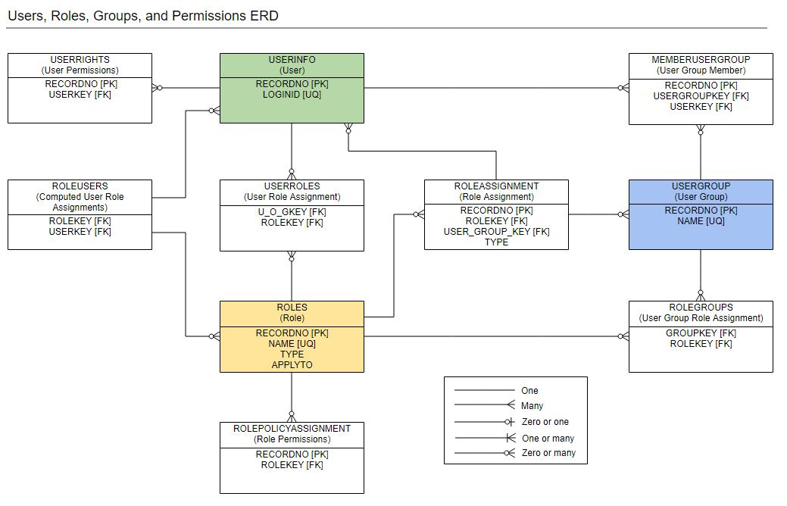
Table | Responsibility | Important relationships
accounts | Authenticated account | 1:N identities
user_profiles | Person profile | N:1 account
devices | Physical device | N:1 owner account
device_identities | Canonical device identity | N:1 device
groups | Family/friend circles | 1:N memberships
group_members | Membership records | N:1 group, N:1 identity
relationships | Relationship between identities | N:M identities
role_assignments | Group-level roles | Membership
permission_policies | Permission definitions | N:1 group/member
consent_records | Approval/revocation history | N:1 identity and policy
device_pairings | Pairing lifecycle | N:1 device/group
telemetry_events | Telemetry event metadata | N:1 device
location_events | Location history | N:1 device
safe_zones | Geofence definitions | 1:N assignments
safe_zone_assignments | Device/geofence mapping | N:M devices/zones
device_commands | Remote command queue | N:1 target device
command_acknowledgements | Command execution result | N:1 command
sync_outbox | Pending synchronization | Local event queue
security_audit_log | Security operations | Actor and target identity
Important: group_members must represent membership, not ownership of the physical device.
One device may participate in multiple relationships without creating duplicate device identities.
D. UI and functional defects
ID | Issue | Correct behaviour
A10 | Family count excludes self but does not define cross-group deduplication | Count unique authorized memberships
A11 | Friend filter uses role text as a fallback | Use explicit relationship type
A12 | Empty branch and filtered empty states need separate state models | Distinguish genuinely empty from filtered
A13 | Unknown battery values may sort as zero | Sort unknown values last
A14 | Online status relies on device clock | Use server heartbeat and freshness policy
A15 | Last node tree rendering uses index-based connectors | Use hierarchy-aware rendering
A16 | Sorting may crash on null names | Normalize nullable fields
A17 | Search performs work on every keystroke | Debounce and filter off main thread
A18 | Tab switching may retain stale subscriptions | Reconcile active subscriptions
A19 | Deep-link parameters have no full validation contract | Validate destination, identity and authorization
A20 | Map action has an ambiguous "Open Map Anyway" option | Explain whether cached or live location is available
There are also important missing UI states:
- Consent pending.
- Consent rejected.
- Consent revoked.
- Pairing expired.
- Pairing already used.
- Device suspended.
- Device ownership disputed.
- Device transferred.
- Device removed remotely.
- Data unavailable due to privacy restrictions.
- Location permission disabled by Android.
- Battery optimization restricting background execution.
- Firebase authentication expired.
- Partial synchronization.
- Server unavailable.
- Command delivered but not acknowledged.
- Command execution failed.
- Command expired.
- Device is in another active group.
- Device has outdated application version.
These should be designed as first-class states, not improvised with generic Toast messages.
4. Major missing requirements by screen
This is where I see one of the largest gaps.
Your document is detailed about the Family & Friends screen, but it frequently references other screens without defining their full contracts.
Incomplete screen coverage
Screen / Activity | Present in document | Missing specification
Family & Friends | Detailed | Pagination, accessibility, loading and error states
Network Gateway | Referenced | Complete pairing state machine
QR Scanner | Referenced | Permission denial, invalid QR, duplicate QR, camera failure
Invite Code Dialog | Partial | Rate limits, expiry, collision, reuse and revocation
Manual Pairing | Partial | Token brute-force protection and identity verification
Profile Activity | Referenced | Profile validation, privacy and account ownership
Person Details | Partial | Granular consent, role and permission management
Map Activity | Referenced | Map permissions, stale location and offline handling
History Activity | Referenced | Retention, pagination, deletion and access authorization
Geofence Activity | Referenced | Boundary validation, duplicate zones, transitions
Settings | Missing | Privacy, telemetry frequency, background tracking
Consent Management | Missing | Approve, reject, review and revoke
Security Center | Missing | Sessions, trusted devices, access logs
Notification Center | Missing | SOS, battery, geofence and command notifications
Recovery Screen | Partial | Recovery preview, conflict resolution and rollback
Account Management | Missing | Logout, transfer, account recovery and deletion
Device Management | Partial | Ownership transfer and multi-group membership
This is not a claim that these screens do not exist in your codebase. It means the supplied specification does not establish their completeness.
In our earlier project discussions, the broader application scope included approximately 45 screens and additional Gateway, pairing and remote-device workflows. Earlier Gateway review also raised identity separation, pairing-state consistency, destructive synchronization and partial-commit concerns. These need to be reconciled against the present module rather than treated as isolated screens.
My conclusion: BR1 to BR9 do not establish complete application-wide screen coverage.
They establish a substantial functional specification for one module.
5. Architecture I recommend
Your document currently uses a combination of Activity, ViewModel, backend engines, SQLite and Firebase.
I would retain the Android MVC/MVVM direction but introduce a more disciplined layered architecture.
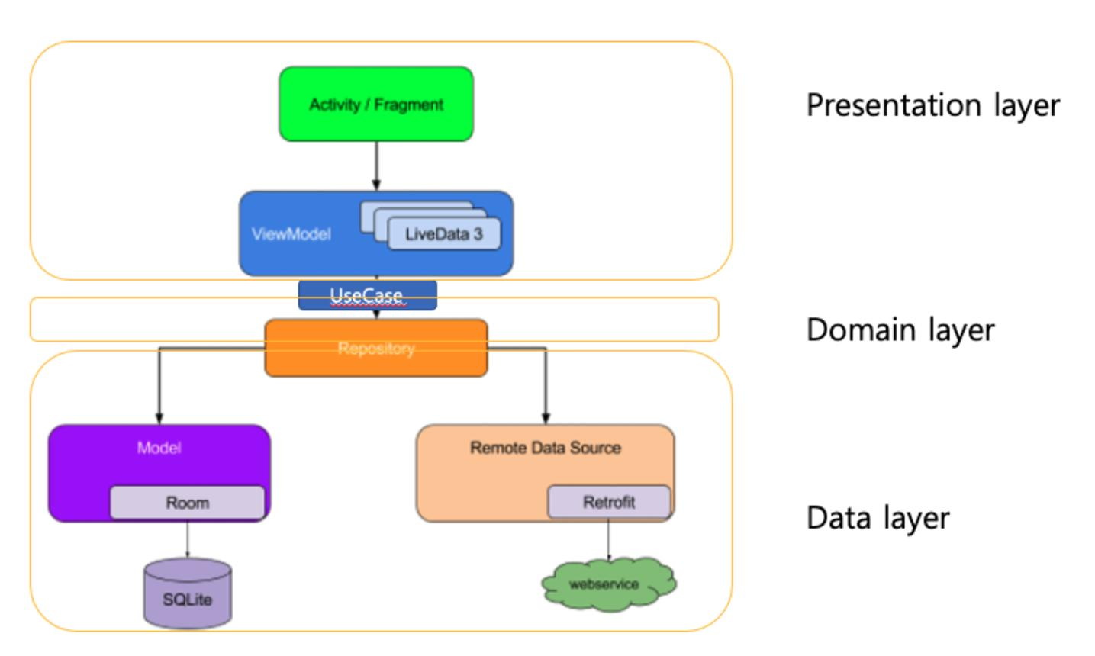
Proposed architecture
Layer | Responsibility | Main components
Presentation | Screen and interaction | Activity, Fragment, UI State, ViewModel
Domain | Business rules | Use Cases, Validators, Policy Engine
Data | Data access | Repository, Data Mapper
Local | Offline persistence | Room, DataStore, Outbox
Remote | Cloud integration | Firebase RTDB, trusted API
Security | Authorization | Auth, Consent, RBAC/ABAC
Device | Android hardware | Location, Battery, Bluetooth, Camera
Sync | Data consistency | Sync Coordinator, Retry, Conflict Resolver
Observability | Operational health | Logs, Metrics, Crash Reporting
For your existing Android Views-based application, there is no need to rewrite everything in Jetpack Compose. A properly structured XML/View-based MVVM application can follow the same architecture principles.
Android's current architecture guidance recommends separation of concerns, repositories, unidirectional data flow, lifecycle-aware UI state and coroutine/Flow-based communication.

Android Developers+2
Suggested module ownership
APPLICATION
│
├── presentation
│ ├── familyfriends
│ ├── networkgateway
│ ├── profile
│ ├── map
│ ├── history
│ ├── geofence
│ └── security
│
├── domain
│ ├── identity
│ ├── relationship
│ ├── consent
│ ├── authorization
│ ├── telemetry
│ ├── pairing
│ └── devicecommand
│
├── data
│ ├── repository
│ ├── local
│ ├── remote
│ ├── mapper
│ └── migration
│
├── infrastructure
│ ├── sync
│ ├── retry
│ ├── monitoring
│ └── recovery
│
└── security
├── authentication
├── authorization
├── encryption
├── consent
└── audit
The dependency direction must be controlled. UI must not directly access Firebase or SQLite. UI communicates with ViewModels, which communicate with use cases and repositories.
6. Performance engineering: 100+ simultaneously connected devices
Major architectural work required
This is arguably the second-largest weakness in the current specification.
It describes real-time synchronization but does not establish a measurable scalability or battery-consumption model.
First, 100 devices is not inherently an enormous Firebase connection count. The challenge is how much information each device transmits, how many listeners each client maintains, how frequently updates happen, and how much processing happens on the Android device.
6.1 Recommended communication model
I recommend separating device connectivity from data subscriptions.
One-to-many device architecture
Primary Guardian Device
Identity, group ownership, approved permissions
Authenticated relationship and authorization layer
Relationship / Group Manager
Family
Approved members
Friends
Isolated peers
Consent & Permission Gateway
Controls every data category and remote command
Approved devices
Only permitted data flows
Unapproved devices
No optional telemetry sharing
6.2 Do not subscribe to everything
Your current specification references three primary Firebase listeners:
- Members
- Devices
- Signals
This is a reasonable starting point, but the subscription strategy needs refinement.
I recommend:
Data | Recommended approach
Relationship roster | Subscribe to membership metadata
Device online status | Lightweight heartbeat/state updates
Battery | Low-frequency updates
Live location | Only for approved and actively requested devices
Location history | On-demand paginated query
SOS | High-priority event subscription
Safe-zone status | Event-based updates
Remote commands | Target-device command subscription
Profile | Read on demand and cache
Consent | Dedicated authorization state subscription
Never download the complete location history or full telemetry stream just because a device is in the roster.
Firebase specifically recommends narrow listener paths, query limits, listener cleanup, efficient data structures and monitoring database load and bandwidth.

Firebase+1
6.3 Adaptive telemetry strategy
I would implement a configurable telemetry policy.
The following are starting engineering targets for testing, not guaranteed optimal settings.
Operating condition | Suggested update strategy
Screen visible, live map active | 5–15 seconds, subject to movement
Background, normal monitoring | 2–5 minutes
Stationary device | 5–15 minutes or significant movement
Low battery (below 20%) | Reduce non-critical sampling
Critical battery (below 10%) | Suspend non-essential telemetry
SOS | Immediate priority event
Offline | Local buffering, no continuous retry loop
Privacy disabled | No optional location transmission
The actual location cadence must be driven by product requirements, Android restrictions, user consent, movement and battery measurements.
Do not create a permanent foreground service merely to keep Firebase listeners alive.
Use:
- Android location APIs with appropriate permission levels.
- Geofencing for boundary events rather than continuous GPS polling.
- WorkManager for deferrable synchronization.
- Foreground services only for genuinely user-visible, permitted ongoing work.
- Exponential backoff with jitter for failed synchronization.
- Local event buffering.
- Lifecycle-aware subscriptions.
6.4 Performance budgets to introduce
These should become measurable acceptance criteria.
Metric | Initial target
Cached roster rendering | P95 under 200 ms
Search response | P95 under 150 ms
Tab switching | P95 under 150 ms
UI frame rendering | 60 FPS target
UI ANR | Zero reproducible ANRs
Listener duplication | Zero
Unapproved telemetry leakage | Zero
Duplicate command execution | Zero
Lost committed local events | Zero
Uncontrolled retry loops | Zero
100-device roster test | Pass
100-device concurrent update test | Pass
The original document specifies cached rendering under 50 ms. Keep that as a stretch target, but measure it on representative devices, including older hardware.
6.5 Load and stress testing
Test at these levels:
Proposed concurrency test stages
Progressive engineering test targets, not measured application capacity.
0 devices70 devices140 devices210 devices280 devices
1
10
25
50
100
150
250
- 1: Concurrent devices 1 devices
- 10: Concurrent devices 10 devices
- 25: Concurrent devices 25 devices
- 50: Concurrent devices 50 devices
- 100: Concurrent devices 100 devices
- 150: Concurrent devices 150 devices
- 250: Concurrent devices 250 devices
Test scenarios:
- 100 devices connecting simultaneously.
- 100 devices sending heartbeat updates simultaneously.
- 100 devices changing online/offline status.
- 50 devices sending telemetry while another 50 are offline.
- 20 devices changing battery state.
- 10 devices generating SOS events.
- 100 devices reconnecting after network restoration.
- Two guardians changing the same membership simultaneously.
- Permission revocation during active location tracking.
- Group deletion while devices are still transmitting.
- Device ownership transfer during synchronization.
- App process termination during a pending command.
Also test 250 devices as a growth scenario.
A successful test must report:
- CPU usage.
- Memory usage.
- Battery consumption.
- Network bytes transferred.
- Firebase reads/writes.
- Listener count.
- Event processing latency.
- Synchronization delay.
- Crash/ANR count.
- Duplicate and missing events.
Do not declare the 100-device requirement passed based only on a successful Firebase connection.
7. Agentic AI engineering team: one team per screen, one governing architecture
I agree with your proposal to use specialized agents for each page.
However, I would make one important adjustment:
Do not give every page its own independent architecture. Give every page its own delivery team, governed by shared enterprise architecture and shared engineering rules.
Otherwise, 15 agents can produce 15 different implementations of authentication, error handling, permission checking and database access.
7.1 Recommended agent hierarchy
Chief Architect / Orchestrator
Owns system architecture, dependencies, scope and final approval
Business Analyst
BR, acceptance criteria
Solution Architect
Architecture, contracts
Security Architect
Identity, privacy, ACL
Data Architect
ERD, mappings, migrations
Performance Architect
Battery, load, profiling
UX Architect
Flows, states, accessibility
Screen-specific delivery squads
UI/UX Designer
Frontend Developer
Backend Developer
Database Engineer
Integration Engineer
QA Engineer
Independent Quality Gate
Integration, security, regression, performance and release validation
7.2 Roles and mandatory deliverables
Agent | Responsibility | Mandatory deliverable
Business Analyst | Understand feature and conditions | BRD, acceptance criteria
Solution Architect | Define implementation structure | Architecture decision records
UX Architect | Design human interaction | User flows, wireframes, state matrix
Frontend Developer | Implement screen | UI, accessibility, UI tests
Backend Developer | Implement business logic | Use cases, services, APIs
Data Architect | Design relationships | ERD, schema, migration plan
Integration Engineer | Connect all components | Interface contracts, integration tests
Security Agent | Protect identities and data | Threat model, security tests
Performance Agent | Optimize responsiveness | Profiling and benchmark report
QA Agent | Verify every requirement | Test suite and defect register
Documentation Agent | Update user and technical manuals | Versioned documentation
Release Manager | Control deployment | Release checklist and rollback plan
7.3 Dedicated agents for your current module
Squad | Screen/module | Additional specialist
S01 | Family & Friends | Relationship engine
S02 | Network Gateway | Pairing/security
S03 | QR Scanner | Camera/QR
S04 | Invite Code | Cryptographic token
S05 | Manual Pairing | Identity verification
S06 | Profile | Identity/profile
S07 | Person Details | Authorization/consent
S08 | Map | Location/privacy
S09 | History | Data retention
S10 | Geofence | Location/geofence
S11 | Settings | Configuration
S12 | Security Center | Security/audit
S13 | Notification Center | Event delivery
S14 | Recovery | Reconciliation
S15 | Device Management | Lifecycle/ownership
Each squad must follow the same architectural contracts, testing templates, database conventions and UI standards.
7.4 Agent execution sequence
This is the order I would enforce in Antigravity.
- Requirement Agent
Confirm scope, dependencies, preconditions, success criteria and failure scenarios.
- Architecture Agent
Verify existing modules, architecture, contracts and integration points.
- UI/UX Agent
Design all screen states, navigation, feedback, loading, empty and error conditions.
- Database Agent
Validate relationships, keys, constraints, migration and data consistency.
- Security Agent
Approve permissions, consent, authentication and threat controls before implementation.
- Backend Agent
Implement use cases, services, repositories and remote contracts.
- Frontend Agent
Connect the screen to validated ViewModel/UI state contracts.
- Integration Agent
Validate all screen-to-screen, service-to-service and cloud-to-local connections.
- QA Agent
Execute positive, negative, boundary, interruption and concurrency tests.
- Performance Agent
Profile battery, memory, CPU, rendering and network consumption.
- Documentation Agent
Update human and technical manuals.
- Architect / Release Agent
Independently verify evidence and approve closure.
An agent must not mark its own implementation as production-ready merely because its own tests pass.
8. Mandatory missing UI/UX features
The current document is strong in describing visible components but weaker in defining how users understand what the application is doing.
I would introduce the following common UI elements across all applicable screens.
Element | Why it is necessary
Connectivity indicator | Show online, offline and reconnecting
Sync status | Synced, pending, failed, conflicted
Consent badge | Approved, pending, denied, revoked
Privacy indicator | Precise, fuzzy, ghost
Last updated timestamp | Avoid misleading stale information
Permission explanation | Explain why an action is unavailable
Loading skeleton | Prevent blank-screen experience
Empty state | Explain what is missing and next action
Retry control | Recover from transient failure
Confirmation dialog | Protect sensitive operations
Undo/recovery | Protect reversible operations
Accessibility labels | Screen readers and assistive usage
Offline indicator | Explain cached versus live data
Command status | Pending, delivered, acknowledged, failed
Audit history | Explain who changed what and when
Example: Member device card
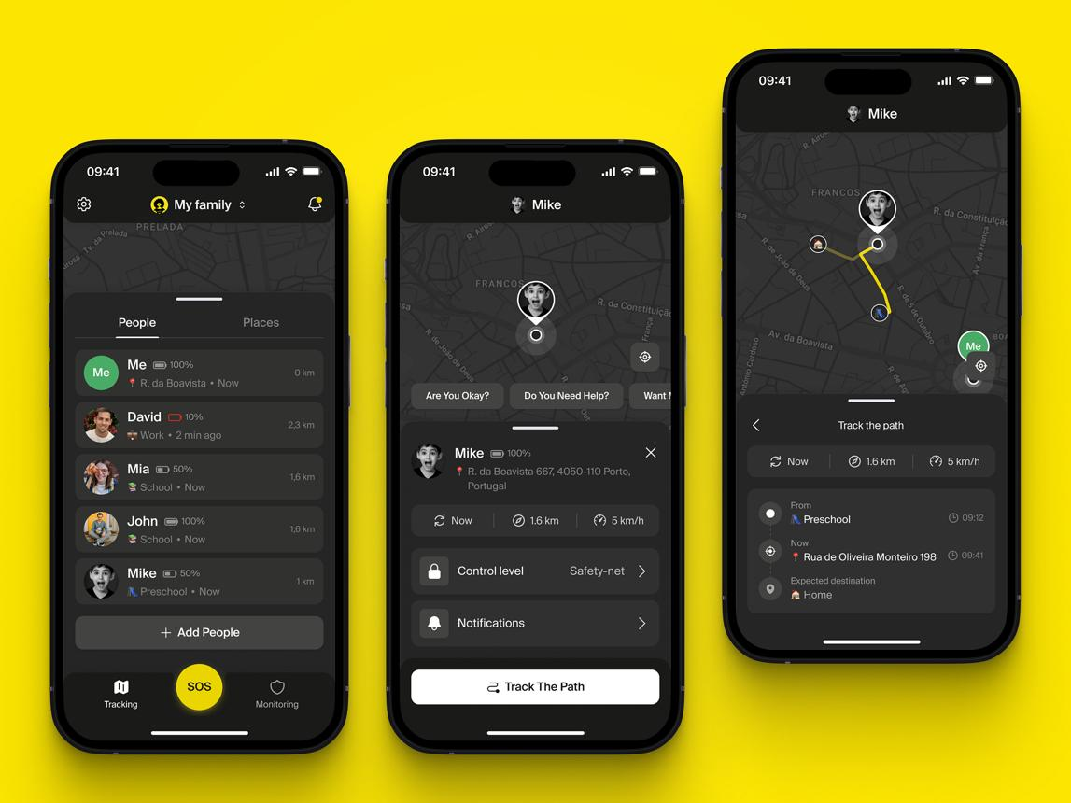
I would redesign the logical card information hierarchy as:
- Person's name and avatar.
- Relationship and group role.
- Connection state.
- Last-seen timestamp.
- Battery level.
- Consent and privacy state.
- Safe-zone status.
- Available authorized actions.
Crucially, a device without location consent must not show a misleading live map pin or a stale location as if it were current.
Example: Consent approval flow
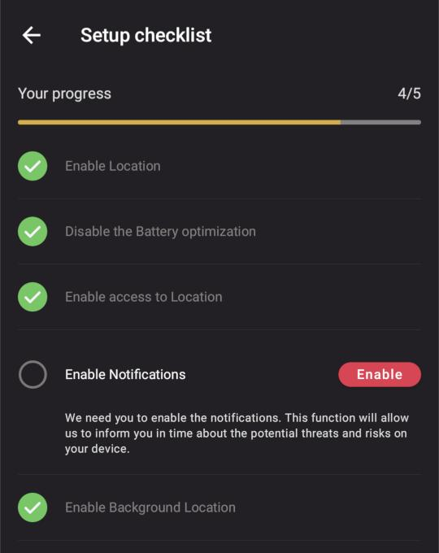
When a device requests permission:
- Identify requesting device.
- Identify requesting account.
- Explain the requested data.
- Explain the purpose.
- Show duration and sharing scope.
- Allow individual permission selection.
- Show approve and reject.
- Show current consent.
- Allow later revocation.
- Record the decision.
The UI must reflect the authoritative permission result from the backend, not optimistically assume that clicking Approve succeeded.
9. Integration and dependency validation matrix
This needs to become a mandatory engineering document.
Integration | Required contract | Failure condition
Activity → ViewModel | UI state and events | Activity recreation
ViewModel → Use Case | Typed parameters/results | Invalid target ID
Use Case → Repository | Defined interface | Repository failure
Repository → Room | Entity/DAO mapping | Migration failure
Repository → Firebase | Data mapping and auth | Permission denied
Room → Firebase | Outbox and versioning | Partial synchronization
Pairing → Identity | Canonical identity | Duplicate device
Pairing → Consent | Independent approval | Unauthorized telemetry
Consent → Telemetry | Enforcement policy | Revocation race
Telemetry → Location | Sampling and permission | Background restriction
Device Command → Target | Authorization and expiry | Stale command
Command → Acknowledgement | Idempotency and result | Duplicate execution
Unlink → All storage | Membership-specific deletion | Orphaned records
Recovery → Repository | Version reconciliation | Stale resurrection
Deep link → Destination | Typed, validated parameters | Wrong target screen
Dependency and version audit
The specification does not include the Gradle dependency graph or version catalog, so I cannot confirm dependency conflicts.
These must be checked in the actual repository:
- Gradle wrapper and Android Gradle Plugin compatibility.
- Kotlin and KSP compatibility.
- AndroidX Lifecycle and ViewModel.
- Room runtime/compiler.
- Firebase BOM and SDK alignment.
- Google Play Services Location.
- CameraX and QR decoder.
- Coroutines and Flow.
- WorkManager.
- Navigation.
- Material Components.
- Google Maps SDK.
- R8 and ProGuard rules.
- Manifest permissions.
- Minimum and target SDK compatibility.
Require dependency locking, dependency verification, vulnerability scanning and a clean reproducible release build.
10. Failed scenarios and regression testing
I would introduce a unified test catalogue rather than keeping isolated test-pass/test-fail descriptions inside each feature.
10.1 Mandatory scenario categories
Category | Scenarios to test
Installation | Fresh install, upgrade, reinstall, restore
Authentication | Valid, invalid, expired, revoked session
Identity | Duplicate ID, missing ID, changed owner
Pairing | Valid, expired, reused, forged, simultaneous
Consent | Approve, reject, partial approval, revoke
Relationships | Family, friend, multiple groups, conflicting roles
Database | Empty, corrupted, migration, orphan records
Synchronization | Offline, timeout, retry, duplicate, conflict
Location | GPS disabled, permission revoked, stale location
Battery | Low battery, charging, battery saver
Commands | Unauthorized, offline, expired, duplicate
Privacy | Ghost, fuzzy, precise, consent revoked
Recovery | Partial backup, stale group, missing device
Performance | 100+ devices, memory pressure, network congestion
UI/UX | Rotation, screen recreation, accessibility, empty states
Security | Unauthorized access, replay, token guessing
Lifecycle | Process death, force-stop, background restriction
10.2 Particularly important failure scenarios
These are the tests I would insist on before approving the architecture.
Test | Expected result
Device paired but consent not granted | No optional telemetry
Consent revoked while location upload is queued | Pending upload is cancelled or securely suppressed
Two guardians approve conflicting permissions | Defined authority policy resolves conflict
Same invite code submitted simultaneously | Only one valid redemption
Same device added to two groups | One canonical device identity
One group unlinks a device | Other authorized groups remain unaffected
Device changes ownership | Old permissions revoked before new ownership activates
Firebase is unavailable during rename | Local change remains recoverable
Room transaction succeeds but cloud write fails | Outbox retains pending operation
Old cloud data arrives after unlink | Removed membership is not resurrected
Two administrators edit the same member | Version conflict detected
Device clock is 10 minutes wrong | Online status remains based on trusted time
Location consent is revoked during active map | Live subscription stops
SOS arrives during low-power mode | Safety event follows its defined priority policy
App is killed during remote ring | Command does not execute twice
Recovery finds multiple candidate groups | Human confirmation before switching
Firebase permission denied | Controlled error, no crash
Network reconnects 100 devices simultaneously | Backoff prevents reconnect storm
10.3 Fix validation and closure loop
Every issue must pass through the following lifecycle.
Defect-to-closure feedback loop
- Detect: Identify defect or requirement gap.
- Reproduce: Create a repeatable failing scenario.
- Analyze: Find root cause and affected dependencies.
- Plan: Define fix, impact and rollback.
- Implement: Make the smallest correct change.
- Unit test: Verify isolated behaviour.
- Integration test: Verify all connected modules.
- Regression test: Re-run previously passing scenarios.
- Performance/security test: Check for new side effects.
- Human approval: Review evidence and approve closure.
- Documentation: Update requirements, manuals and traceability.
Closure condition
A defect is closed only when its acceptance criteria and regression evidence are recorded.
10.4 Mandatory engineering quality gates
Gate | Release condition
G0: Requirements | All requirements have unique IDs
G1: Architecture | Dependencies and interfaces approved
G2: UI/UX | All states and navigation verified
G3: Database | Schema and migration validated
G4: Security | No unresolved critical/high security defects
G5: Implementation | Static analysis and unit tests pass
G6: Integration | All cross-module contracts pass
G7: QA | All mandatory scenarios pass
G8: Performance | Concurrency and battery targets met
G9: Regression | Existing functionality remains intact
G10: Human approval | Required approvals recorded
G11: Release | Versioned release and rollback prepared
A branch must not be marked complete merely because its code has been committed.
It needs a traceable path:
Requirement → Design → Implementation → Test → Evidence → Approval → Closure
11. Human-in-the-loop User Manual
I recommend maintaining two different manuals:
- End-user manual: How an actual human uses the application.
- Operator/administrator manual: How a human supervises device connections, privacy, security and recovery.
The following is the proposed operational procedure.
Procedure 1: Registering the primary device
Human action required
- Install the application from the approved distribution channel.
- Open the application.
- Register or authenticate the account.
- Verify the account using the required authentication method.
- Register the primary device.
- Review device identity and owner details.
- Set the primary guardian role.
- Configure privacy preferences.
- Review requested Android permissions.
- Confirm the device appears as the root network anchor.
Expected result: One canonical primary identity with no duplicate roster entries.
Procedure 2: Adding a family member
- Open Family & Friends.
- Select Add Member.
- Choose QR Scanner, Invite Code or Manual Pairing.
- Verify the target device identity.
- Review the invitation.
- Accept the pairing request on the receiving device.
- Establish the relationship.
- Select the relationship category.
- Display the consent screen.
- Choose individual permissions.
- Review the data-sharing scope.
- Confirm approval.
- Wait for backend acknowledgement.
- Verify the member appears in the Family tab.
- Verify only approved telemetry becomes available.
Expected result: A connected family member with explicit, independently recorded permissions.
Procedure 3: Adding a friend
- Open Friends.
- Select Add Friend.
- Generate or scan an invitation.
- Authenticate the receiving device.
- Accept the peer relationship.
- Confirm the peer is placed in the Friends group.
- Review the peer's permissions.
- Approve only necessary data sharing.
- Verify that family administration privileges are not inherited.
Expected result: An isolated peer relationship.
Procedure 4: Reviewing a connected device
- Open the appropriate tab.
- Select the device.
- Check identity and relationship.
- Check online/offline state.
- Check last-seen timestamp.
- Check battery information.
- Review consent status.
- Review safe-zone information, if authorized.
- Open live location only if authorized.
- Check whether the information is live, cached or unavailable.
Expected result: The operator understands exactly what information is available and why.
Procedure 5: Changing permissions
- Open the device dossier.
- Navigate to Privacy and Permissions.
- Review existing approvals.
- Select the permission to change.
- Review its purpose and consequences.
- Submit the change.
- Complete any required authentication.
- Wait for server confirmation.
- Verify that subscriptions and pending operations reflect the new policy.
- Review the audit history.
Expected result: Permission changes are reflected consistently across devices and cloud services.
Procedure 6: Unlinking a device
- Open the member's action menu.
- Select Unlink Device.
- Review which group membership will be removed.
- Check whether the device belongs to other groups.
- Explain the impact to the operator.
- Obtain confirmation.
- Verify administrative authorization.
- Execute the membership removal.
- Stop subscriptions and invalidate related access.
- Verify local and cloud reconciliation.
- Preserve required security audit records.
Expected result: Only the intended relationship is removed, without accidentally deleting the underlying device identity.
Procedure 7: Disaster recovery
- Open Recovery.
- Display the current local roster.
- Display the authenticated account.
- Retrieve authorized cloud relationship candidates.
- Compare local and remote versions.
- Identify missing, duplicate and conflicting records.
- Present the proposed recovery changes.
- Ask for human approval where destructive or ambiguous changes are involved.
- Apply recovery.
- Validate membership and consent.
- Verify that unauthorized nodes were not restored.
- Generate a recovery report.
Expected result: Recovery without unauthorized membership, data resurrection or destructive overwrites.
Procedure 8: Emergency and SOS management
- Receive the SOS notification.
- Verify event identity and timestamp.
- Check whether the event is authenticated.
- Display the last authorized location and its freshness.
- Show available contact and emergency actions.
- Record acknowledgement.
- Record action taken.
- Close only after the event is resolved or formally handed over.
Expected result: A traceable emergency response, without assuming that an old cached coordinate is the current location.
Human approval matrix
Operation | Human approval
View ordinary roster | No additional approval
Pair a device | Required
Grant data consent | Required from authorized data owner
Grant administrative role | Required
Change relationship | Required
Enable live tracking | Required
Change privacy mode | Required
Revoke consent | Required from authorized owner
Unlink device | Required
Force recovery | Required
Delete account/device identity | Strong confirmation and reauthentication
Emergency alert acknowledgement | Required
Consent and approval must always follow the applicable legal authority and the rights of the person whose data is collected. A guardian role alone should not automatically authorize every operation on every device.
12. Additional mistakes in the specification that should be corrected
These are smaller-looking issues with potentially large downstream consequences.
Existing wording/design | Correction
Zero-latency re-fetch | Define measurable latency targets
100% SQLite/cloud parity | Define eventual consistency and reconciliation
100% exact GPS | Display measured GPS accuracy
Socket re-initialization | Manage Firebase SDK listeners and connection lifecycle
Six-character invite code | Add strict rate limits, expiry, one-time redemption and server-side verification
Empty token collision handling | Use atomic server-side token reservation
Toast for security-critical changes | Use persistent confirmation and audit status
Device deletion and unlink combined | Separate membership removal, device revocation and account deletion
Role title determines authorization | Use explicit policy-based authorization
Activity holds state | Use ViewModel and persistent state
Device clock determines online state | Use trusted server timestamps and heartbeat policy
One specific issue deserves attention: a six-character alphanumeric invite code has approximately 31 bits of entropy. That may be acceptable for a short-lived, aggressively rate-limited invitation, but not as a standalone security credential.
Firebase RTDB should also be protected by server-side Security Rules. These support read, write, validation and query-index enforcement. UI checks are not security boundaries.
Firebase+1
13. Execution roadmap: what should happen next?
I would not attempt to implement all these changes simultaneously. That creates unnecessary rework and integration problems.
Recommended implementation roadmap
P0 · Foundation
Architecture and security correction
- Identity and device ownership.
- Relationship and membership model.
- Consent and authorization.
- Database ERD and migration.
- Firebase Security Rules.
- Pairing and command state machines.
P1 · Integration
Core implementation
- Repository and MVVM boundaries.
- Family/Friends ViewModel.
- Local Room database.
- Transactional outbox.
- Cloud synchronization.
- Lifecycle-managed listeners.
- Device command delivery.
P2 · User experience
Screen completion
- All screen states.
- Consent management.
- Privacy indicators.
- Accessibility.
- Navigation and deep links.
- Human approval workflows.
P3 · Optimization
Scalability and battery
- Adaptive telemetry.
- Listener optimization.
- Database indexing.
- Network optimization.
- Memory and CPU profiling.
- 100/150/250-device load tests.
P4 · Production readiness
Validation and release
- Full regression.
- Security testing.
- Recovery testing.
- Human manual.
- Technical documentation.
- Release and rollback.
14. My final assessment
Engineering dimension | Current assessment
Functional feature definition | Good foundation
UI/UX scenario coverage | Incomplete
Android architecture | Needs formalization
Database architecture | Incomplete
Identity separation | Critical clarification required
Privacy and consent | Critical redesign required
Firebase integration | Incomplete contracts
Offline synchronization | Needs reconciliation design
Device lifecycle | Needs state machines
Security | Significant gaps
Battery optimization | Insufficiently specified
100+ device scalability | Not demonstrated
Agent governance | Needs central ownership
Regression management | Needs traceability
Human-in-the-loop documentation | Needs expansion
Current verdict: Not production-ready as a specification
The underlying idea is viable. The next step should be engineering discipline rather than adding more features.
15. What I need to perform the actual code-level audit and fixes
There is an important limitation: the attachment contains a 36-line hierarchical specification. It does not contain the Android source code, Gradle files, database implementation or Firebase Security Rules.
Consequently, I have identified specification defects and architectural risks, but I have not modified or executed your application. I cannot honestly claim that runtime bugs have been fixed or regression tests have passed.
To perform the actual implementation audit, I need the project source.
Please upload the Android project ZIP, or provide the following source files if you prefer a smaller upload:
Priority | Files
1 | FamilyFriendsActivity.java
2 | FamilyFriendsViewModel.java
3 | DatabaseHelper.java and SQLite schema/migrations
4 | FirebaseComm.java
5 | PairingRepository.java
6 | DeviceIdentityHelper.java
7 | PrivacyEngine.java
8 | Related Models and Adapters
9 | AndroidManifest.xml
10 | build.gradle / build.gradle.kts and version catalog
11 | Firebase RTDB Security Rules
12 | Referenced XML layouts and navigation files
Exclude signing keys, passwords, service-account private keys and production user data.
What I would deliver from the actual repository
- Architecture Audit: Existing versus required architecture.
- Screen Coverage Matrix: Every screen, element, state and navigation route.
- Dependency Matrix: Missing, broken, circular and conflicting dependencies.
- Database Audit: ERD, incorrect mappings, missing indexes and migration defects.
- Security Audit: Authentication, consent, permissions and data leakage.
- Bug Register: Critical, high, medium and low priority defects with root causes.
- Implementation Fixes: Actual source-code changes, not just recommendations.
- Test Evidence: Unit, integration, regression and concurrency results.
- Performance Report: CPU, memory, battery, network and 100+ device tests.
- Updated User Manual: Step-by-step human-in-the-loop procedures.
- Release Readiness Report: Open risks, approvals and verified closure.
One final architectural recommendation
I would formalize this entire approach as your reusable JG Engineering Execution Framework, rather than creating a separate set of disconnected rules for each screen.
Every feature should inherit the same mandatory engineering standards, while individual page agents own their implementation and testing.
The governing principle should be:
No requirement without traceability. No screen without scenario coverage. No implementation without dependency validation. No integration without contract testing. No security-sensitive action without authorization. No bug closure without regression evidence. No production release without human approval.

